System Design for AI-Based Procurement Negotiation Intelligence System

1. Functional Requirements
Functional requirements define what the system must do. They describe the features, inputs, processing, outputs, and actions performed by the system.
For your procurement system, the functional requirements should be:
ID | Functional Requirement
FR-01 | The system shall allow authorized procurement users to log in and access the procurement dashboard.
FR-02 | The system shall allow users to upload or enter supplier quotations containing price, quantity, delivery terms, payment terms, and other commercial conditions.
FR-03 | The system shall store and retrieve supplier quotation and purchase-history data.
FR-04 | The system shall compare quotations from multiple suppliers for the same material or purchase requirement.
FR-05 | The system shall compare the current quoted price with historical purchase prices.
FR-06 | The system shall analyze supplier delivery performance using historical order and delivery data.
FR-07 | The system shall analyze supplier quality-performance data and identify recurring quality issues.
FR-08 | The system shall calculate a supplier risk score based on defined risk factors such as delivery, quality, supply capacity, price, and commercial conditions.
FR-09 | The system shall identify potential cost-saving opportunities from quotation and historical-price analysis.
FR-10 | The system shall generate AI-based negotiation recommendations, including target price, negotiation points, and supplier considerations.
FR-11 | The system shall rank or compare suppliers using configurable evaluation criteria.
FR-12 | The system shall display procurement KPIs, supplier scores, trends, alerts, and recommendations on the dashboard.
FR-13 | The system shall allow users to ask procurement-related questions through an AI assistant.
FR-14 | The system shall generate alerts for significant supplier risks such as delivery delays, quality deterioration, unusual price increases, or capacity shortages.
FR-15 | The system shall allow users to view the reasoning or factors contributing to an AI recommendation.
FR-16 | The system shall maintain procurement analysis and supplier-performance records for future reference.

Important distinction
For example:
“System calculates supplier risk score” → Functional Requirement
“Risk score must be calculated within 3 seconds” → Non-Functional Requirement
The first describes what the system does; the second describes how well it must do it.

2. Non-Functional Requirements
Non-functional requirements define the quality attributes, constraints, and performance expectations of the system.
Category | Requirement
Performance | Normal dashboard and analysis requests should return results within an acceptable response time, such as 3–5 seconds, excluding unusually large file processing or external AI-service delays.
Availability | The system should remain available during normal procurement working hours and handle temporary service failures gracefully.
Security | Only authenticated and authorized users shall be able to access procurement and supplier information.
Data Protection | Supplier quotations, pricing, purchase history, and commercial information shall be protected from unauthorized access.
Scalability | The system should support increasing numbers of suppliers, quotations, purchase records, and users without major architectural changes.
Reliability | The system should provide consistent calculations and should not lose procurement data during normal operations or recoverable failures.
Accuracy | Risk scores and analytical calculations shall be based on defined rules, validated data, and traceable input values.
Explainability | AI-generated negotiation and risk recommendations should identify the major factors supporting the recommendation rather than providing an unexplained conclusion.
Usability | Procurement users should be able to compare suppliers, understand risks, and access recommendations with minimal training.
Maintainability | Frontend, AI-agent workflows, business rules, and data-processing components should be modular so they can be modified independently.
Compatibility | The React/Vite frontend shall communicate with the backend/AI services through defined APIs and structured data formats such as JSON.
Auditability | Important procurement analyses and system-generated recommendations should be logged so that decisions can be reviewed later.

3. Business Process Modeling — AS-IS
The AS-IS process represents how procurement is currently performed before introducing the AI system.

AS-IS Flow
Purchase Requirement
↓
Procurement Team Requests Quotations
↓
Receive Supplier Quotations
↓
Collect Historical Purchase Data
↓
Manually Compare Prices
↓
Manually Check Quantity & Delivery Terms
↓
Review Supplier History
↓
Identify Issues / Risks
↓
Prepare Negotiation Strategy
↓
Negotiate with Supplier
↓
Select Supplier
↓
Place Order
↓
Problems May Be Discovered During / After Delivery

Problems in AS-IS
Manual comparison
↓
Time-consuming analysis
↓
Important historical information may be missed
↓
Inconsistent supplier evaluation
↓
Weak negotiation preparation
↓
Supplier risks may be detected late
↓
Potential cost savings are missed

4. Business Process Modeling — TO-BE
The TO-BE process shows how the process works after implementing your AI procurement system.
Purchase Requirement
↓
Upload / Enter Supplier Quotations
↓
AI Collects & Processes Procurement Data
↓
┌─────────────────────────────────────┐
│ AI Procurement Analysis │
├─────────────────────────────────────┤
│ Price Analysis │
│ Historical Price Analysis │
│ Supplier Comparison │
│ Delivery Analysis │
│ Quality Analysis │
│ Supplier Risk Analysis │
│ Commercial Terms Analysis │
└──────────────────┬──────────────────┘
↓
Negotiation Intelligence
↓
Target Price + Strategy
↓
Cost-Saving Opportunities
↓
Supplier Risk Alerts
↓
Procurement Decision
↓
Supplier Negotiation
↓
Supplier Selection
↓
Purchase Order
↓
Continuous Monitoring

Key improvement
The biggest change is:
AS-IS: Problems and opportunities are mainly identified through manual analysis and sometimes after something goes wrong.
TO-BE: The system analyzes available historical and current data before the purchasing decision, giving the procurement team actionable intelligence.

5. Use Case Diagram

Actors:
Primary Actor
Procurement Manager / Procurement Officer
Supporting Actors
- Supplier
- AI Procurement System
- Data Administrator

Main Use Cases

Use Case Relationships
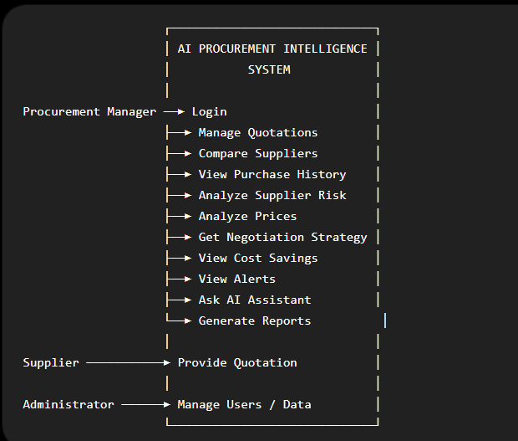
A stronger UML representation would be:
Analyze Supplier
│
├── <<include>> Compare Quotations
├── <<include>> Analyze Historical Prices
├── <<include>> Analyze Delivery Performance
└── <<include>> Analyze Quality Performance

Generate Negotiation Strategy
│
├── <<include>> Analyze Supplier
├── <<include>> Calculate Target Price
└── <<include>> Identify Cost-Saving Opportunities

Analyze Supplier Risk
│
├── <<include>> Delivery Risk
├── <<include>> Quality Risk
├── <<include>> Supply Risk
├── <<include>> Price Risk
└── <<include>> Commercial Risk

6. Activity Diagram
The activity diagram should show the detailed processing from quotation input to procurement decision.
START
│
▼
User Logs into System
│
▼
Enter Purchase Requirement
│
▼
Upload Supplier Quotations
│
▼
Validate Input Data
│
┌─────┴─────┐
│ │
Valid? No
│ │
Yes ▼
│ Show Errors
│ │
│ └──────► Correct Data
▼
Retrieve Historical Data
│
▼
Compare Supplier Prices
│
▼
Analyze Delivery History
│
▼
Analyze Quality Data
│
▼
Analyze Supply Capacity
│
▼
Analyze Commercial Terms
│
▼
Calculate Risk Score
│
▼
Identify Cost-Saving Opportunities
│
▼
Generate Negotiation Strategy
│
▼
Display AI Recommendations
│
▼
Procurement Manager Reviews
│
┌───┴────┐
│ │
Accept Reject/Modify
│ │
│ ▼
│ Re-evaluate
│ │
└────────┘
│
▼
Supplier Negotiation
│
▼
Select Supplier
│
▼
Place Purchase Order
│
▼
END

7. User Journey Mapping
This shows what the procurement user experiences at each stage.
Stage | User Action | System Action | User Need | Output
1. Requirement | Creates purchase requirement | Records material, quantity and requirements | Start procurement | Purchase request
2. Quotations | Uploads supplier quotations | Validates and extracts quotation data | Avoid manual data entry | Structured quotations
3. Comparison | Opens comparison screen | Compares price, terms and supplier performance | Find best supplier | Supplier comparison
4. Intelligence | Requests analysis | Runs AI analysis | Understand purchasing situation | AI insights
5. Risk Review | Checks supplier risk | Calculates risk factors and overall score | Avoid unreliable suppliers | Risk assessment
6. Negotiation | Reviews recommendations | Generates target price and negotiation points | Negotiate effectively | Negotiation strategy
7. Decision | Selects/shortlists supplier | Records decision | Make informed purchase | Supplier decision
8. Monitoring | Tracks supplier | Updates performance from new data | Detect future issues early | Alerts and updated risk

User Journey Flow
Need to Purchase
↓
Collect Quotations
↓
Upload Data
↓
Compare Suppliers
↓
Understand Price History
↓
Check Supplier Risk
↓
See Potential Savings
↓
Receive Negotiation Strategy
↓
Negotiate
↓
Select Supplier
↓
Place Order
↓
Monitor Supplier

8. Overall System Flow
This is the main flow I recommend putting in your project documentation/presentation:
USER
│
▼
React + Vite UI
│
▼
Purchase Requirement
│
▼
Supplier Quotations
│
▼
┌───────────────────┐
│ SNS Workbench │
│ AI Backend │
└─────────┬─────────┘
│
▼
Data Processing
│
┌──────────────┼──────────────┐
▼ ▼ ▼
Price Analysis Supplier Risk Terms Analysis
│ │ │
│ ┌─────┴─────┐ │
│ ▼ ▼ │
│ Delivery Quality │
│ Risk Risk │
│ │ │ │
│ └─────┬─────┘ │
│ ▼ │
│ Supply Risk │
└───────────|─────────────────┘
▼
Negotiation Intelligence
│
┌───────────┼───────────┐
▼ ▼ ▼
Target Price Risk Score Cost Saving
│ │ │
└───────────┼───────────┘
▼
AI Recommendation
│
▼
React Dashboard
│
▼
Procurement Decision
│
▼
Supplier Negotiation

▼
Final Purchase
│
▼
Supplier Performance Data
│
└───────────► Future AI Analysis

9. Two Main System Workflows

Frontend Workflow
Login
↓
Dashboard
↓
Create Purchase Requirement
↓
Upload Quotations
↓
Quotation Comparison
↓
Supplier Analysis
↓
Risk Analysis
↓
Negotiation Intelligence
↓
Cost-Saving Insights
↓
AI Assistant
↓
Procurement Decision

Backend / SNS Workbench Workflow
API Request
↓
Validate & Process Input
↓
Retrieve Historical Procurement Data
↓
Price Analysis Agent
↓
Supplier Risk Agent
↓
Delivery Analysis
↓
Quality Analysis
↓
Supply Capacity Analysis
↓
Commercial Terms Analysis
↓
Negotiation Strategy Agent
↓
Cost-Saving Analysis
↓
Generate Explainable Recommendation
↓
JSON Response
↓
React Frontend

Recommended project architecture
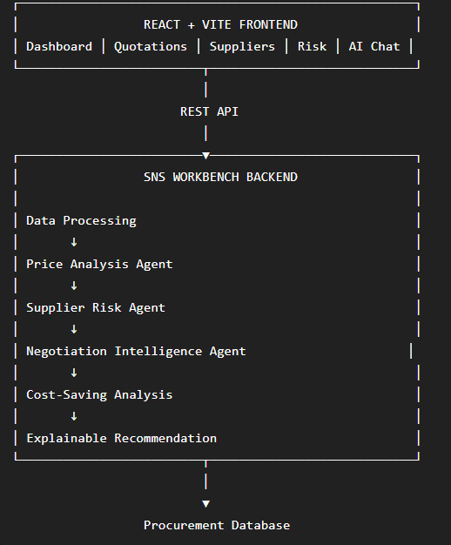
Core design principle:
The system should not simply tell the procurement manager “Supplier B is best.” It should show why, using quotation price, historical price, delivery reliability, quality, capacity, commercial terms, supplier risk, and potential savings—and then convert that analysis into a negotiation action.

